ArorUniversityofArt,Architecture, Design & Heritage Sukkur

DepartmentofAI-MultimediaandGaming BS AI – III (Section B)

Lab 01: Fundamentals of arrayand 2d arraysdata structure Date: Sep 02, 2024 Subject: Data Structure (CSC221), Fall 2024 Instructor:Abdul Ghafoor

**NAME:MUHAMMAD SAEED SHAIKH**

**ROLL NO:0069**

1. <https://leetcode.com/problems/concatenation-of-array/>

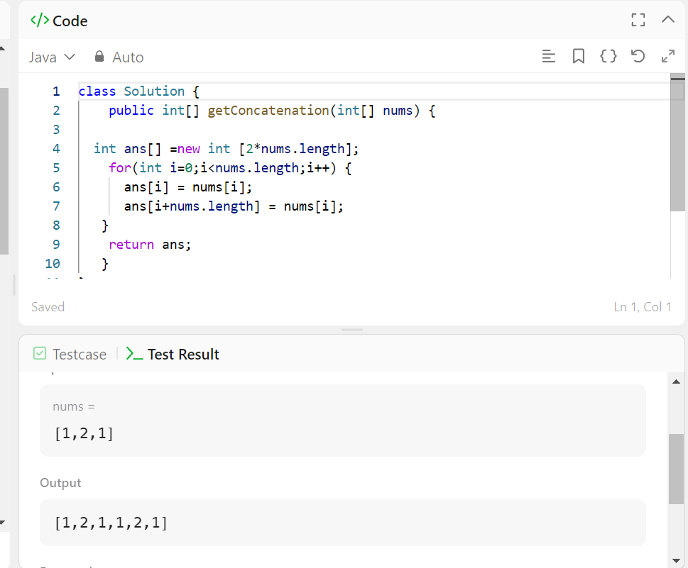

1. <https://leetcode.com/problems/find-words-containing-character>

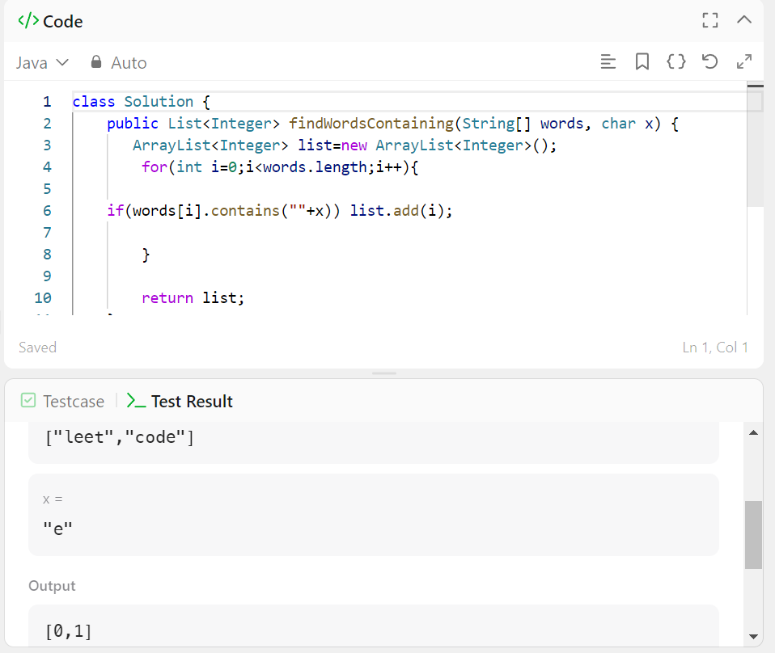

1. <https://leetcode.com/problems/maximum-number-of-words-found-in-sentences>

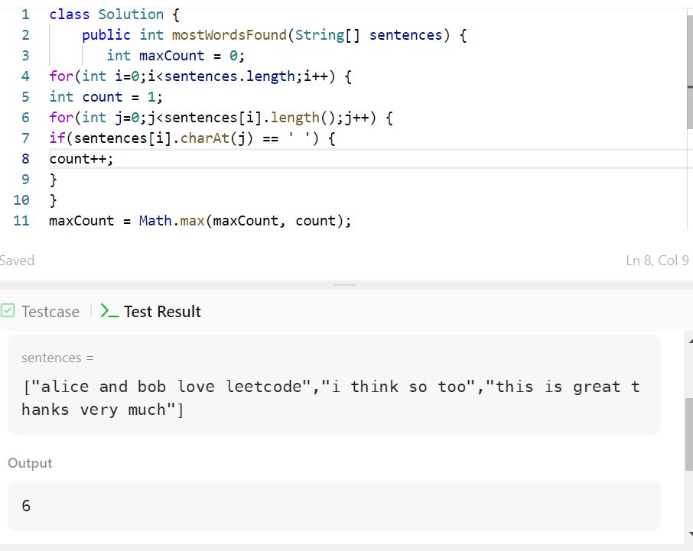

1. <https://leetcode.com/problems/find-common-elements-between-two-arrays>

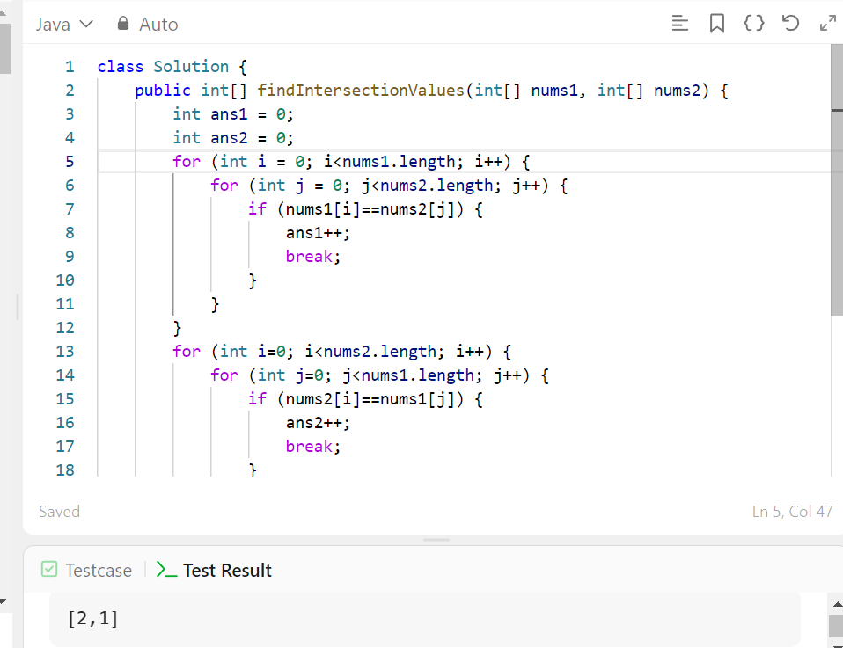

1. <https://leetcode.com/problems/count-primes/>

